Jules Hannaford 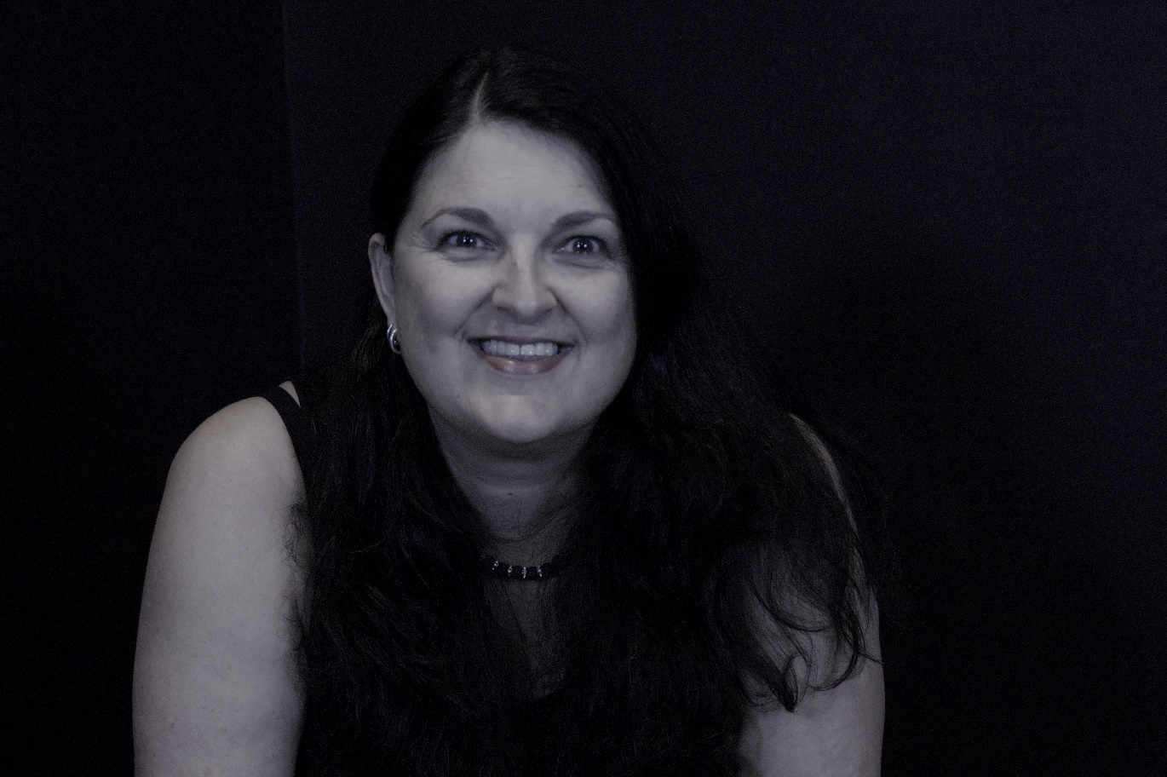
Biography
Jules grew up in rural South Australia before moving to Adelaide, the state capital, and beginning her career as a teacher. She now lives in Hong Kong, the setting of her first book, Fool Me Twice, which details the pitfalls and abuse she experienced in her online search for love.
Jules began writing her book in 2010, after she was the victim of an internet dating scam. She knew this was an important story to share with other women to prevent them from becoming caught in the same trap and help them make safer, smarter decisions when dating online. It took a long time for her to muster the courage to share her story after battling feelings of shame and regret for choices that landed her in a dangerous situation. She counts herself lucky to have survived.
Jules has always had a passion for people and their stories, so she started her podcast Hong Kong Confidential in 2017 to provide a platform for sharing the stories of interesting and unique people in Hong Kong. With the help of her daughter Zara, she decided to turn her memoir into a true crime podcast, as she feels that this story can make an important contribution to the safety of those navigating the complicated—and sometimes illusionary—internet dating world.

